**Report:** lab assignment 1

Name: DAI JUNWEI

* 1. **Contrast Stretching** 
     1. Questions

1. Check the minimum and maximum intensities present in the image:

The minimum value is 13 and maximum value is 204.

1. Next, write two lines of MATLAB code to do contrast stretching:

>> P=im2double(P);

>> p2=(P-13)/(204-13)*255

1. Check to see if your final image P2 has the correct minimum and maximum intensities of 0 and 255:

Yes, it has

2.1.2 Result

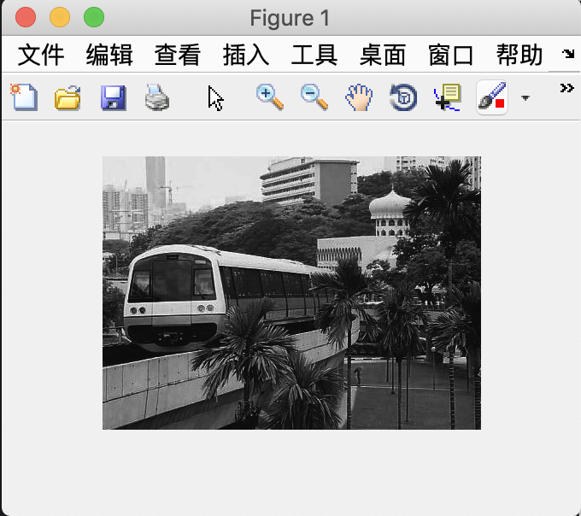

2.1.2 Code

>> Pc = imread(‘mrt-train.jpg’);

>> whos Pc

>> P = rgb2gray(Pc);

>> P=im2double(P);

>> p2=(P-13)/(204-13)*255;

>> imshow(p2,[])

**2.2 Histogram Equalization**

* + 1. Question

1. display a histogram with 256 bins. What are the differences?

With more bins, the pixel in each bin is lesser. and it provide more information about the image.

1. Redisplay the histograms for P3 with 10 and 256 bins. Are the histograms equalized?

Both the histograms are more equalized than the first histogram.

1. What are the similarities and differences between the latter two histograms?

Similarities, the number of pixels falls in each range of the gray-level are the same. However, the number of pixels falls in each gray-level are not the same, especially when the gray-level are high.

1. Rerun the histogram equalization on P3. Does the histogram become more uniform? Give suggestions as to why this occurs.

No,P3 remains the same, because the total number of this picture is changeless, and the first use of function histeq has already average the number of pixels in each gray level. So it won’t change.

* + 1. Result

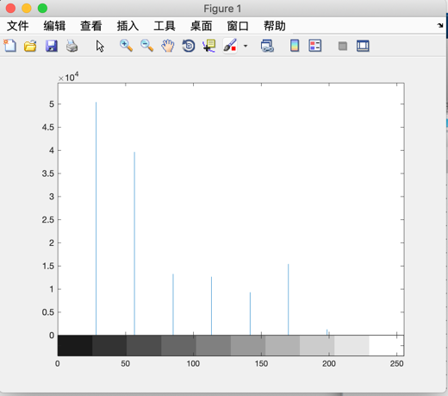 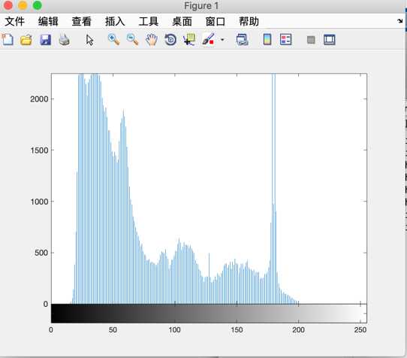

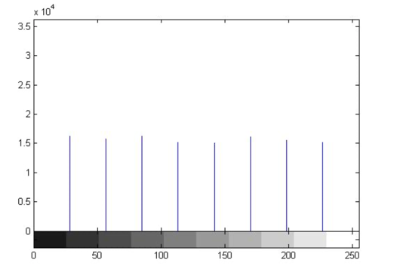 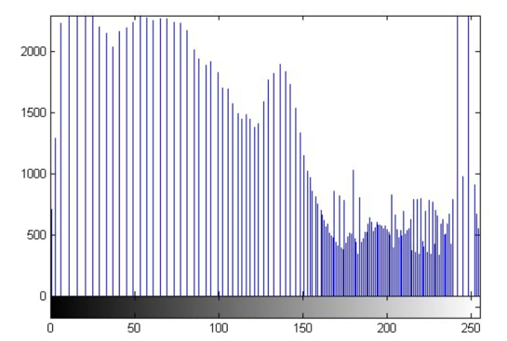

* + 1. Code

>> imhist(P,10);

>> imhist(P,256);

>> P3 = histeq(P,255);

**2.3 Linear Spatial Filtering**

* + 1. Question

1. What are the trade-offs between using either of the two filters, or not filtering the image at all?

They are both effective in removing noise, and the filter 2 is more efficient in moving the noise, but it made the image blurred.

1. Repeat step (c) above. Are the filters better at handling Gaussian noise or speckle noise?

The speckle noise was not removed by Gaussian filters. Gaussian filters are better at handling Gaussian noise.

* + 1. Result

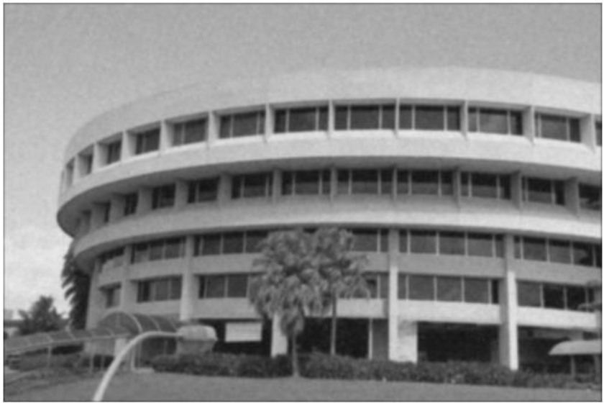

Filter 1

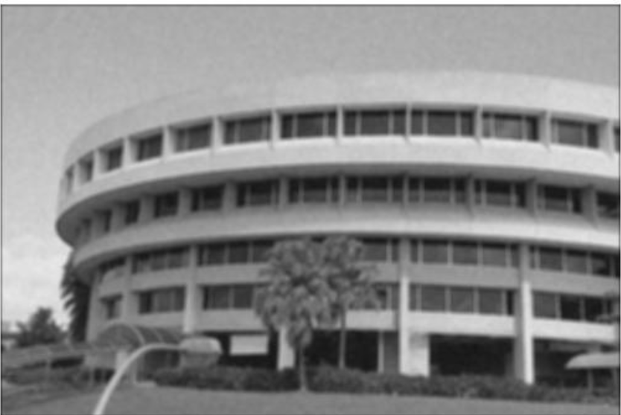

Filter 2

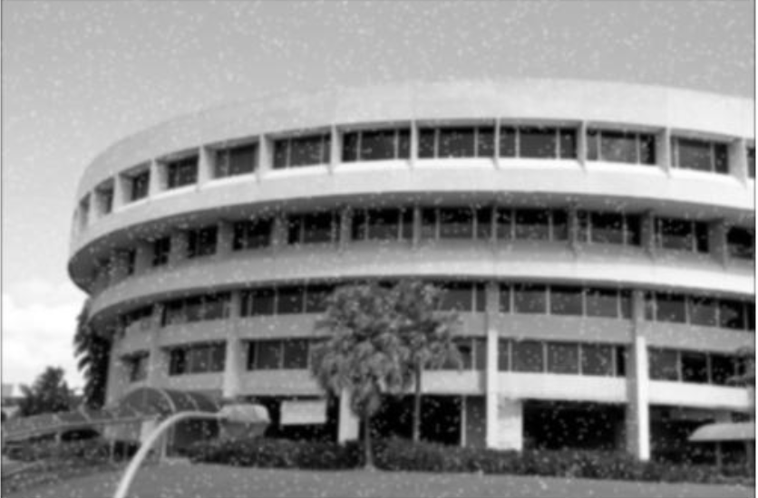

Using gaussian filter to handling speckle noise.

* + 1. Code

>> library=imread('gaussian.jpg');

>> sigma=1;

>> gausfilter1=fspecial(‘gaussian’,[5,5],sigma);

>> sigma=2;

>> gausfilter2=fspecial('gaussian',[5,5],sigma);

>> gaus1=imfilter(library,gausfilter1,'replicate');

>> gaus2=imfilter(library,gausfilter2,'replicate');

>> imshow(gaus1)

>> imshow(gaus2)

>> speckle=imread('speckle.jpg');

>> spec=imfilter(speckle,gausfilter,'replicate');

>> imshow(spec)

* 1. **Median Filtering** 
     1. Question

1. How does Gaussian filtering compare with median filtering in handling the different types of noise? What are the tradeoffs?

Gaussian filtering is better in removing Gaussian noise while median filtering is better in removing the speckle noise. Median filtering makes the edges in the image blurred.

* + 1. Result

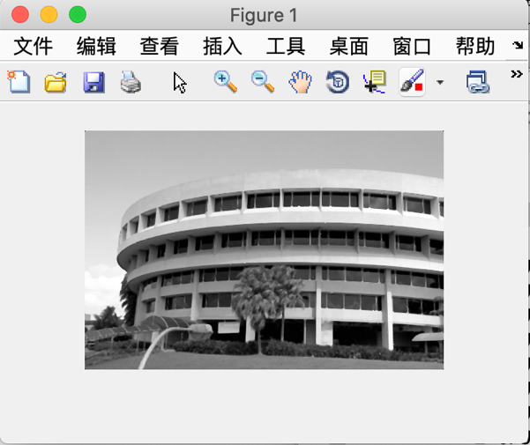

* + 1. Code

>>j=medfilt2(speckle);

>> imshow(j);

>> imshow(spec)

* 1. **Suppressing Noise Interference Pattern**
     1. Question

1. Can you suggest any way to improve this?

Yes, I think after finished in the frequency domain , we can also process the image in the spatial domain again to make the image better.

* + 1. Result

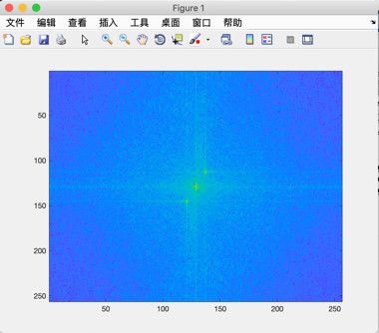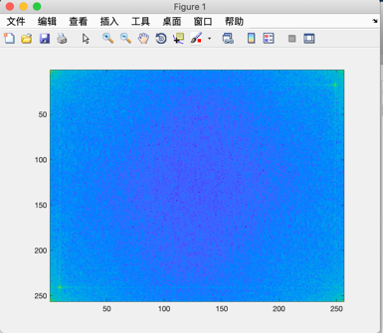

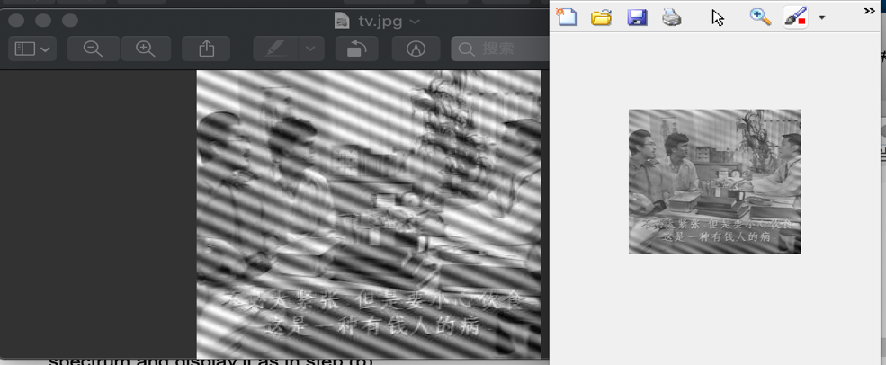

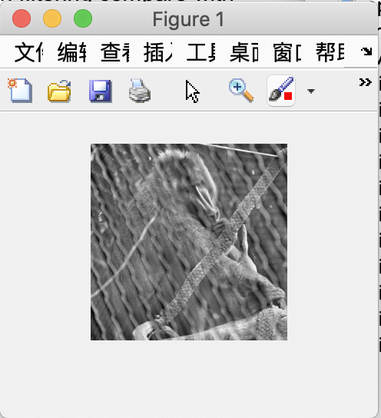

The released monkey

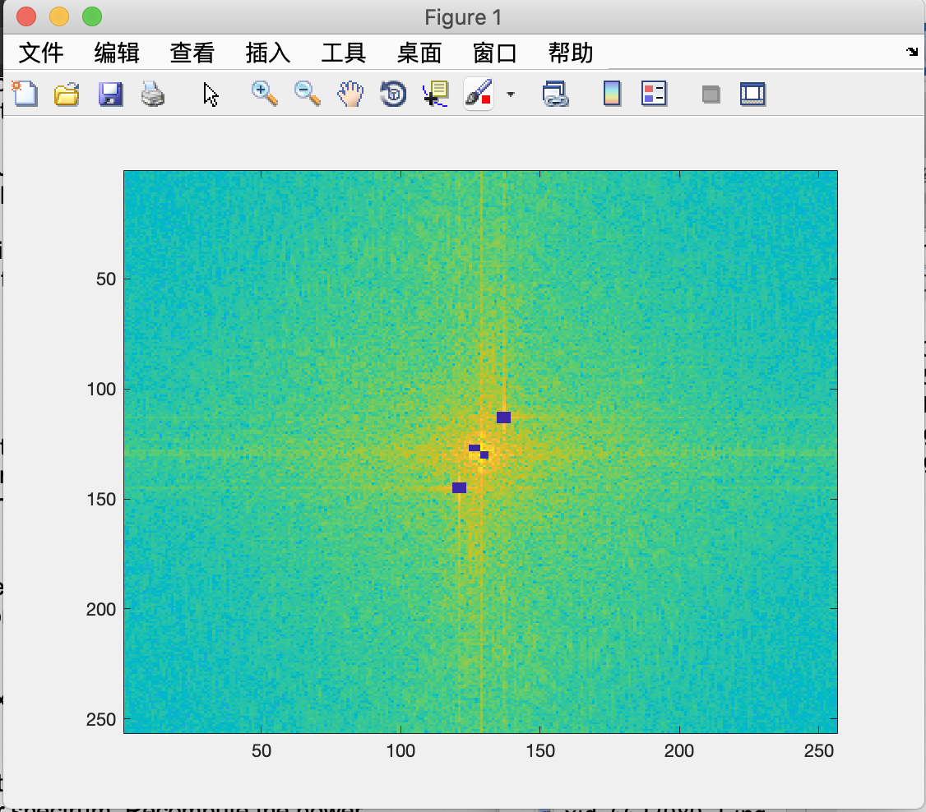

Set the peak and its neighbor zero

* + 1. Code

>> tv = imread('tv.jpg');

>> F = fft2(tv);

>> S = abs(F);

>> imagesc(fftshift(S.^0.1));

>> colormap('default');

>>F(15:19, 247:251) = 0;

>> F(1:3,1:3)=0;

>> F(239:243,7:11)=0;

>>F(254:256,253:256)=0;

>>TV2=ifft2(F);

>>TV2=real(TV2);

>>TV2=TV2+130;

>>TV2=uint8(TV2);

>>imshow(TV2)

%So the monkey need to turn into gray picture. It was a rgb picture.

>> whos mon

Name Size Bytes Class Attributes

mon 256x256x3 196608 uint8

>> mon = rgb2gray(mon);

F = fft2(mon);

>> S =abs(F);

%Just redo the same process that we did to the ’ TV’

>>F(4:8, 245:249)=0;

>>F(1:1, 1:1)=0;

>>F(250:254, 9:13)=0;

>>F(255:256, 1:4)=0;

>>F(248, 20:23)=0;

>>F(10, 235:238)=0;

>>F(2, 255)=0;

>>F(253, 252)=0;

>>P2=ifft2(F);

>>P2 = real(P2);

>>P2=P2+132;

>>P2=P2*255/298;

>>P2=uint8(P2);

>>imshow(P2);

* 1. **Undoing Perspective Distortion of Planar Surface** 
     1. Question

1. Does the transformation give you back the 4 corners of the desired image?

Yes

1. Display the image. Is this what you expect? Comment on the quality of the transformation and suggest reasons.

Yes, it is blurred in the corner , because we only use four points, we can choose more points to be more accurate.

* + 1. Result

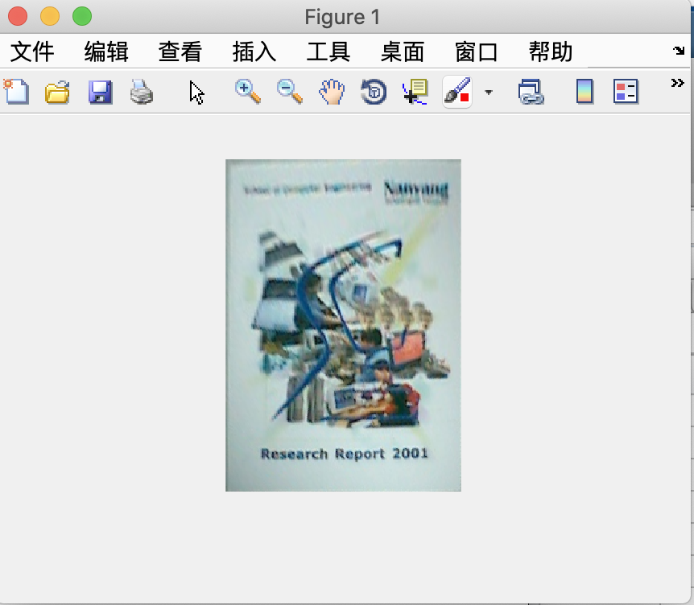

* + 1. Code

> book=imread('book.jpg');

>> imshow(book)

>> [X Y]=ginput(4)

X =

142.8299

307.4525

256.9026

3.2586

Y =

27.8998

47.5829

216.6789

159.8663

x=[142 307 256 3];

>> y=[27 47 216 159];

%X means the changed image

>> X=[1,210,210,1];

>> Y=[1,1,297,297];

>> V=[X(1) Y(1) X(2) Y(2) X(3) Y(3) X(4) Y(4)]’;

>> A=[x(1) y(1) 1 0 0 0 -X(1)*x(1) -X(1)*y(1);

0 0 0 x(1) y(1) 1 -Y(1)*x(1) -Y(1)*y(1);

x(2) y(2) 1 0 0 0 -X(2)*x(2) -X(2)*y(2);

0 0 0 x(2) y(2) 1 -Y(2)*x(2) -Y(2)*y(2);

x(3) y(3) 1 0 0 0 -X(3)*x(3) -X(3)*y(3);

0 0 0 x(3) y(3) 1 -Y(3)*x(3) -Y(3)*y(3);

x(4) y(4) 1 0 0 0 -X(4)*x(4) -X(4)*y(4);

0 0 0 x(4) y(4) 1 -Y(4)*x(4) -Y(4)*y(4)];

>> w = U*[X; Y; ones(1,4)];

>> w = w ./ (ones(3,1) * w(3,:))

w =

-239.2247 57.6873 198.1278 81.8978

-31.1659 -119.9287 371.6333 411.0977

1.0000 1.0000 1.0000 1.0000

>> T = maketform('projective', U');

>> P2 = imtransform(P, T, 'XData', [0 210], 'YData', [0 297]);